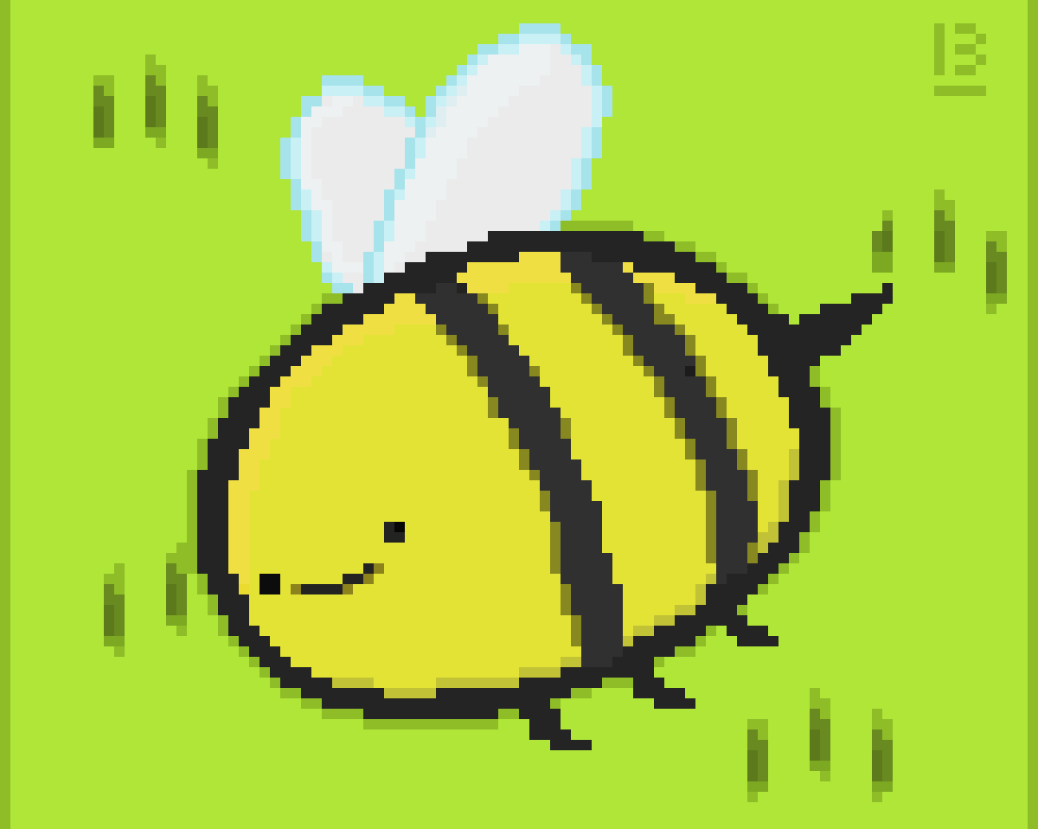
HOORAY FOR MY FISH

HELLO !

I AM…………………..…CLASS…….

I HAVE LOTS OF FRIENDS IN MY SCHOOL. Mám hodně kamarádů ve své škole.

COME ALONG WITH ME. Pojď se mnou.

1,2,3, COUNT WITH ME. Počítej se mnou.

HOW MANY CAN YOU SEE IN MY SEA? Kolik jich vidíš v mém moři?

HAVE A LOOK IN MY BOOK 😊.
Koukni do mé knížky😊

